|  |  |
| --- | --- |
| Amazon Inspector  AWS Certified Security Specialty SCS-C02 | Amazon Inspector |

# Amazon Inspector Overview:

Amazon Inspector is an AWS service that allows you to perform automated security assessments on several resources:

# Reporting and Integration:

* + - * AWS Security Hub Integration:  
        Amazon Inspector findings are automatically sent to AWS Security Hub, which provides a unified view of security across your AWS environment.
* Amazon EventBridge Integration:   
  Inspector also integrates with Amazon EventBridge, allowing you to set up automated workflows in response to security findings (e.g., alerts, notifications).

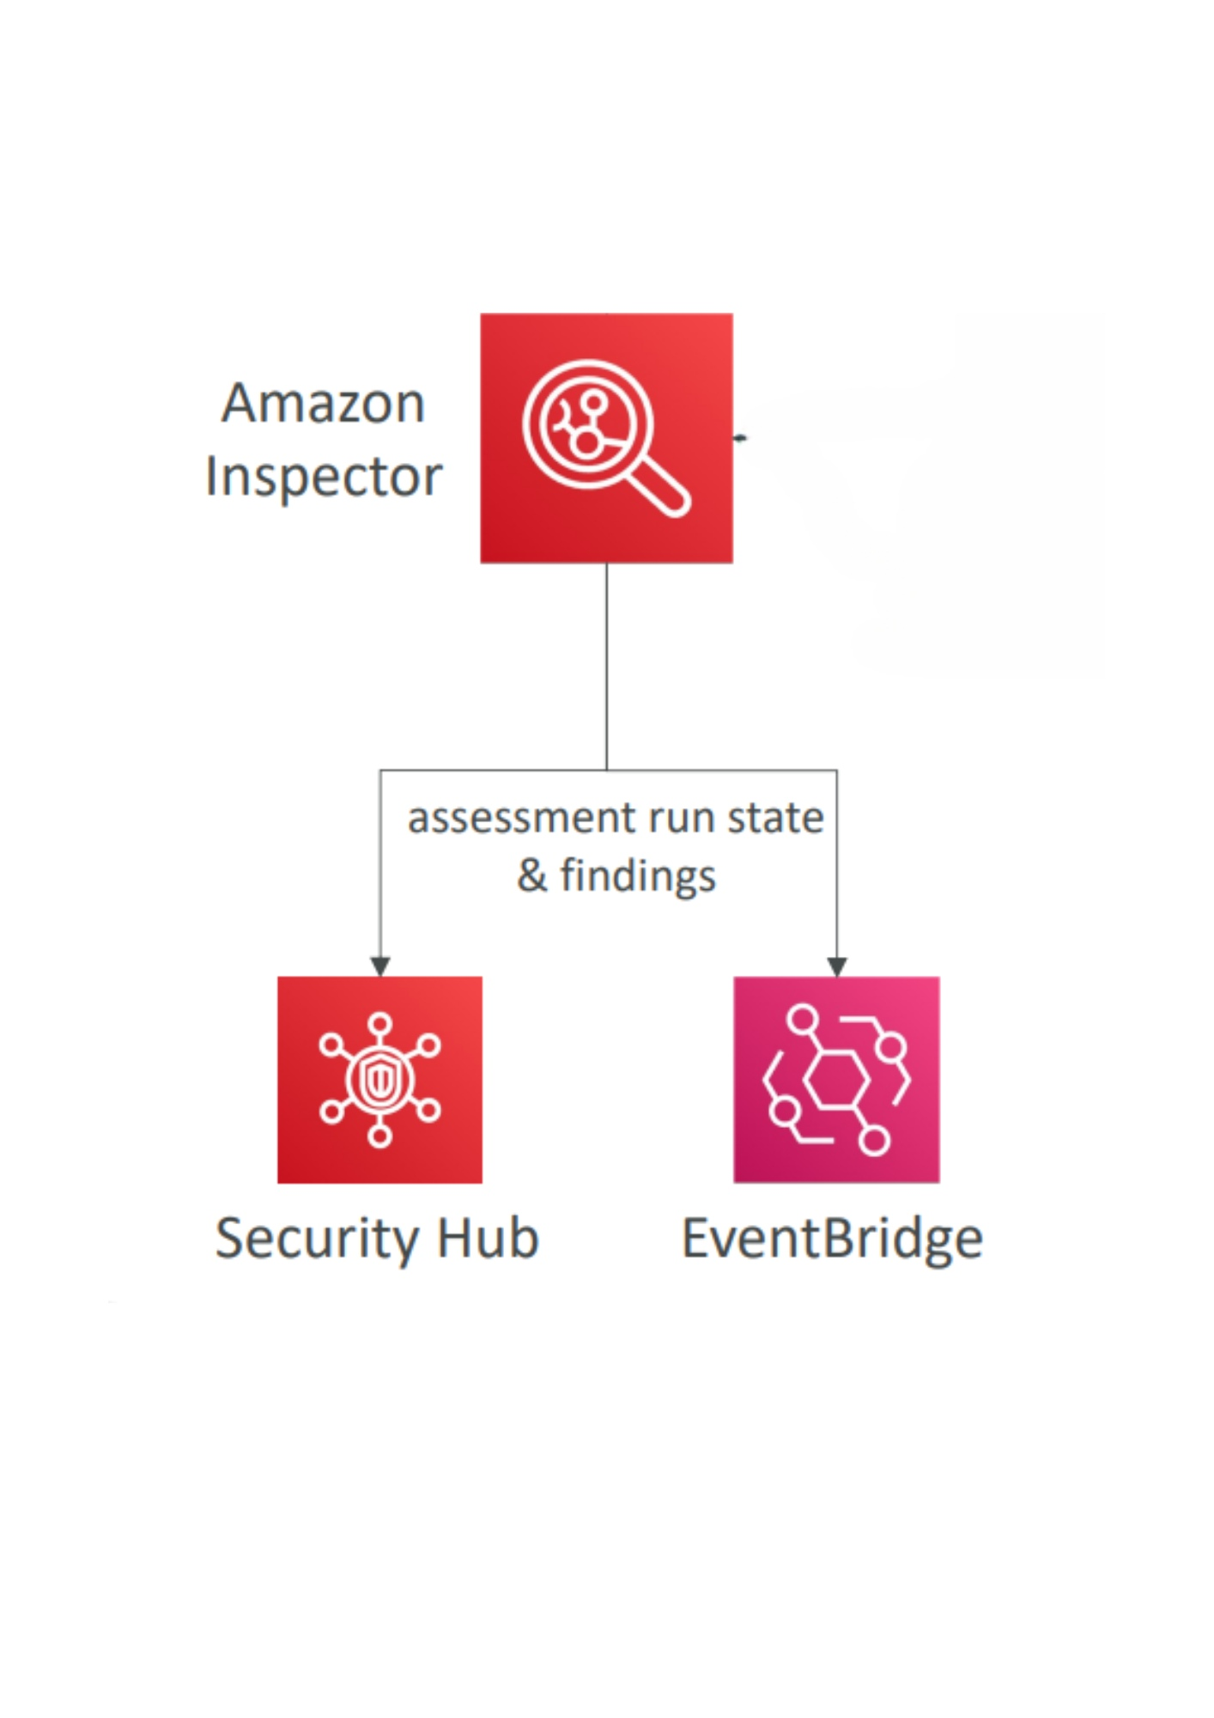

By using Amazon Inspector, we can maintain a proactive approach to securing your AWS resources through automated, continuous assessments.

Conclusion:

Amazon Inspector is an automated tool that helps us keep our AWS resources secure by constantly checking for vulnerabilities. It scans EC2 instances, container images, and Lambda functions to find potential risks like outdated software or security weaknesses. It also integrates with other AWS tools for easy monitoring and alerts.

In short, Inspector helps us stay ahead of security threats by automatically finding and reporting issues, making it easier to protect our environment without needing to do manual checks.